|  |  |  |
| --- | --- | --- |
| Respiratory data analysis software  Keywords: Works of breathing, Product-Time pressure, respiratory parameters | | |
|  | | |
| Louis Mayaud | CICIT – Hopital Raymond Poincare | 🞂 |
| 1/27/2012 |
|  | | |

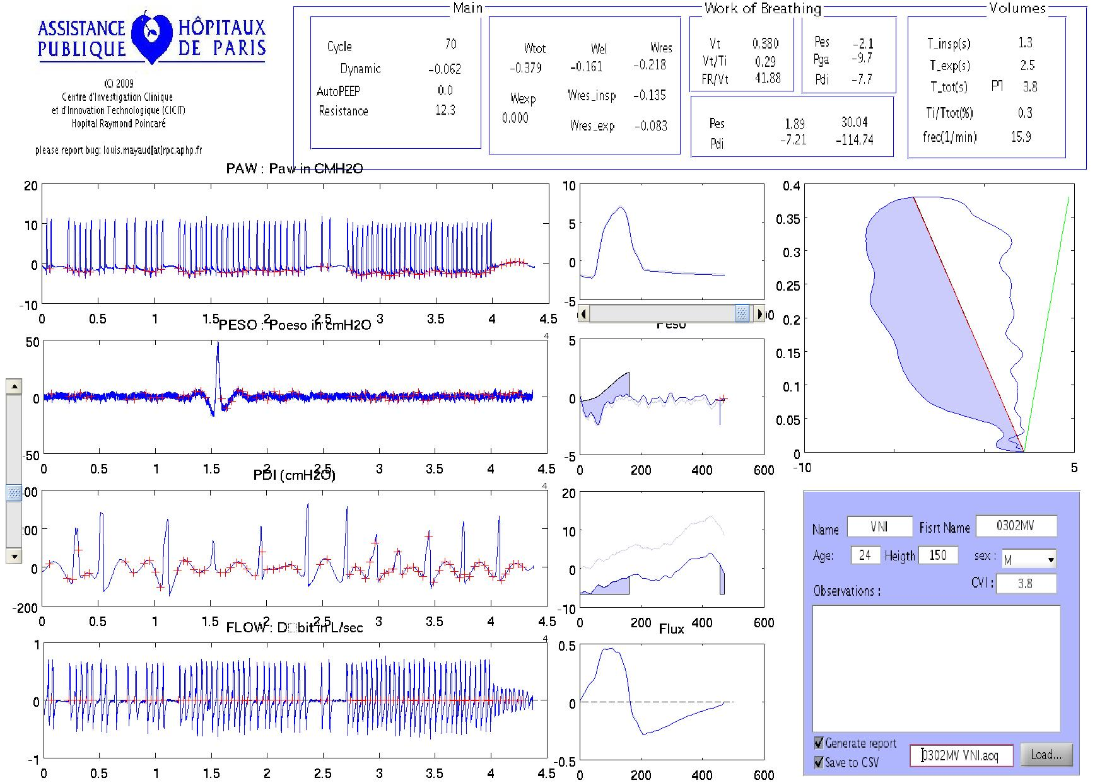

Respiratory data analysis software

Keywords: Works of breathing, Product-Time pressure, respiratory parameters

# Introduction

The tool we present here, aims an automated analysis of respiratory signals with the following features:

* Automated period detection
* Automated artefact rejection
* Estimation of AutoPEEP
* Visual Feedback of processing and results
* Graphical User Interface (GUI) allowing correction

This document shortly presents the steps of respiratory signal processing steps and a brief description of results computed. For a detailed user’s guide, please refer to the adequate document

# Respiratory signal analysis

## Pre-processing

A simple 5th order band-pass Cheblychev filter between .05Hz and 5Hz is applied to the raw signal in order to get rid of baseline and high-frequency noises. Then, a simple zero crossing algorithm [2] is applied to the Flow signal in order to identify the candidates for detection of onset and offset of respiratory cycles.

### Outliers Rejection

In order to identify the best periods to pursue further analysis on, we have applied the following rules to discard incoherent and/or artefacted periods:

1. Period is less than 1second
2. Period length that deviates of more than *S* standard deviation from mean period time
3. Any period with a data point (Pes, Pga or Paw) that deviates of more than *S* standard deviation from the mean value of the signal
4. Any period where expiratory volumes has more than 30% relative difference with the inspiratory volume (meaning that leaks have occur during the cycle)

This simple 4-rules-based technique for detection of artefacts only requires the definition of a single parameter (*S*). This parameter has been set to S=3 and has proven to give satisfactory results. In some particularly cases however, threshold will have to be tuned to fit unusual distribution of noisy periods. This can be achieving with the GUI that provides an instantaneous feedback on selected periods.

### Mean cycle

Each selected period is resampled and interpolated to fit the mean period allowing computation of mean respiratory waveform for Paw, Pes, Pga and Flow. The process of averaging the periods, as we know, will improve the Signal to Noise Ration (SNR), in particularly by reducing the relative energy of asynchronous noise sources like EKG. Finally, new signals are derived from the mean waveforms as described below:

* Volume is computed with a cumulative trapezoidal integration of the Flow with respect to time.
* Pdiathe diaphragmatic pressure is defined as Pga minus Peso
* Plung is defined as Paw minus Pes

### Chest Wall Compliance (Ccw)

Measurement of the Ccw, used to compute the elastic work of breathings, requires mechanical ventilation and curarisation of the patient, which is an undesirable and quite often conter-indicated. However this parameter can be estimated, according to [8], with sufficient accuracy from the following parameters:

* Age
* Heigth (in metres)
* Sex (M or F)

The Ccw will be expressed as 4% of the Intrisic Vital Capacity (CVI) obtained from the equation seen below as function of age, sex and height:

* Adult (18>A>77)
  + Men :



* + Women :



* Teenagers (A<18 y.o. and S>150cm)
  + Boys:



* + Girls:



* Children (A<18 y.o. and S<150cm)
  + Boys:



* + Girls:



## Processing

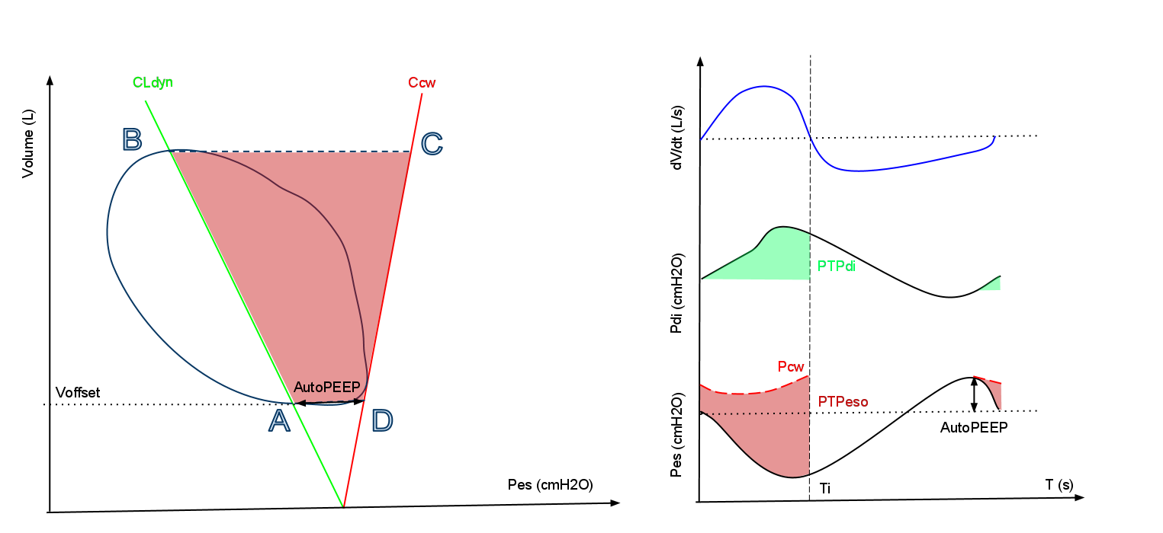

Figure 1: (Left) Campbell diagram with Pressure-Volume curve (blue), Chest wall compliance line (red), dynamic lung compliance (green). (Right) Time plots for airflow (top), diaphragmatic (middle) and eosophageal (bottom) pressures.

### Volume correction

#### Leak correction:

Difference between the inspiratory and expiratory volumes is expected to be below 30% for each cycle since respiratory periods with obvious airway leaks have been removed from further analysis. Minor differences might still exist at a single cycle level but would not make any sense from the physiological point of view for the average respiratory cycle. In order to discard from the signal what is likely to be errors from calibration of sensors, we have corrected remaining "leaks" in volume signal with the following slope:



#### Volume Offset:

Because integrative of a signal is true for any constant, we have set Voffset to comply with the AutoPEEP-corrected Pressure-Volume diagram first introduced by Campbell [3]. As shown on Figure 1, dynamic lung compliance (CLdyn) and chest wall compliance (Ccw) lines are fitted to the begin and the end of the respiratory cycle, respectively. The intersection of the two compliance lines, fitted to the abscise axe constrains the constant value of the volume offset, according to the following equation:



### Patient’s parameters

#### Swings (cmH2O)

Swing values are defined, for each pressure componant, as the difference between the maximum value over the respiratory cycle and the value at the beginning of the inspiratory effort.

#### Dynamic lung compliance (L/cmH20)

The dynamic lung compliance is defined as the ratio of change in volume to change in oesophageal pressure between instant of zero-flow within the same breathing as described by [4] and is therefore computed accordingly by the following equation:



where and stand for inspiratory start and stop time, respectively.



#### Intrasic post-expiratory pressure (iPEEP - cmH20)

The AutoPEEP is defined in [5] as the positive recoil pressure of the respiratory system at end-expiration and is thefore equal to Pes at the beginning of the inspiratory effort minus Pes et the beginning of the inspiratory flow. The point where inspiratory effort starts is simply and automatically estimated as the first point, backward from the beginning the inspiratory flow, where the first derivative of the signal is null, which is when the curve has its first inflexion.

#### Pressure-Time Product (PTP – cmH20.s)

The PTP esophageal is defined by as the area between the oesophageal pressure and the estimated recoil pressure of the chest wall, as explained in [6] betwenn the beginning of the inspiratory effort and the end of the inspiratory flow. The PTPes is shown in red on the right side of the figure 1. Similarly, the diaphragmatic PTP is defined as the area below the diaphragmatic pressure as plotted in green on the same figure.

#### Works of Breathing (WOB - J)

The different works of breathing are computed from the Campbell diagram according to the Figure 1:

* , the resistive work (1+2) is defined by the area delimited by the PV curve (blue). The dynamic lung compliance line (red) separates this area in two parts:



* + at the left-hand side (1)



* + at the right-hand side (2)



* , the elastic work is defined by the area delimited by the points A, B, C and D (grey)



* , the expiratory work (3) is defined by the area delimited by the PV curve (blue) and the chest wall compliance line (green)



Once we have the areas expressed in [L.cmH2O], we convert them in [J] with the coefficient:



For the recordings where a positive airway pressure is detected (and consistently greater than 3cmH2O), none of the above the computed as it is globally not possible to distinguish between the patient’s effort and the mechanical ventilation input. Instead, the area between the pressure-volume curve during inspiration (A to B on Figure1) and the chest-wall compliance line (CD on Figure 1) is returned as W, the total work.

#### Time parameters

The time parameters are simply derived from the detection of the zero-flow events corrected from outliers as explained above:

* , inspiration length (s)



* , expiration length (s)



* , respiratory cycle length (s)



* , respiratory frequency (1/min)



#### Volume parameters

The volumes parameters are derived from volume vector, computed as explained above:

* , tidal volume (L)



* , mean inspiratory flow (L/s)



* , Rapid Shallow Breathing (RSB) (1/min.L)



# Conclusion

This document describes the signal processing techniques involved in this tool together with the basic equations of physiology used to compute the results. It should provide the reader with a good understanding of what are the numbers provided. For any question or suggestion, please report to the project website: <http://code.google.com/p/respmat/>

In addition to this document exist a user’s guide, also available on the project’s website.

Anyone can get access to the source code of this program and become a contributor.

# References

[1] cumtrapz, “Matlab function reference”, 1994-2005

[2] Donoho, D.L. (1993), "Progress in wavelet analysis and WVD: a ten minute tour," in Progress in wavelet analysis and applications, Y. Meyer, S. Roques, pp. 109-128. Frontières Ed.

[3] Martin J. Tobin, Chap 44, p995

[4] Donoho, D.L. (1995), "De-noising by soft-thresholding," IEEE Trans. on Inf. Theory, 41, 3, pp. 613-627.

[5] Martin J. Tobin, Chap 44, p985

[6] wden, “Matlab function reference”, 1994-2005

[7] Brueckener S., “zero-crossing manual”, 2002

[8] Chu MW et JK Han, Introduction to pulmonary function, Apr. 2008, 41(2)

# Liability

By using this software, you understand this is a research tool **that should not be used for clinical practice**. All the results provided here should be validated by an expert lung specialist. In no circumstance the results provided by this tool should be used for diagnosis.